**How to configure a default page in Magento2**

**On the Admin panel, click Stores. In the Settings section, select Configuration.**

* Select Web under General in the panel on the left
* Open the Default Pages section, and continue with following:

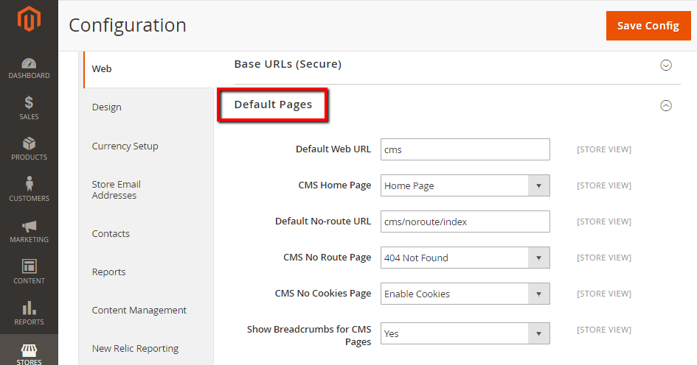

In the Default Web URL field, the default value cms or enter other value as needed

* In the CMS Home Page field, select the page you want to become your home page, you should select “Home Page”
* In the Default No-route URL field, the default value is “cms/index/noRoute.” or enter other value as needed
* In the CMS No Route Page field, select 404 Page Not Found value to show CMS page when a [404 Not Found](https://www.mageplaza.com/kb/magento-2-404-page-not-found.html) error appears
* In the CMS No Cookies Page field, select Enable Cookies value to show CMS Page when cookies are disabled in the browser
* In the Show Breadcrumbs for CMS Pages field, set Yes if you want to show a breadcrumb trail at the top of all CMS pages
* When complete, click Save Config.

**How to add CMS Page in Magento 2**

Adding a New CMS Page is an easy action you can do with Magento 2 Configuration. From the backend, the new page is created by text, images, blocks of content, variables, and frontend apps. All of them are designed friendly for both search engines that crawl the metadata of the page and people who access your page.

The below are six steps you need to walk through to add a new CMS page successfully.

## Add a New CMS Page

* Step 1: Add a New Page
* Step 2: Choose the Page Layout
* Step 3: Enter the Content
* Step 4: Enter the Meta Data
* Step 5: Preview the Page
* Step 6: Generate the Page

### Step 1: Add a New Page

* On the Admin Panel, Content > Elements > Pages.
* Click on Add New Page.

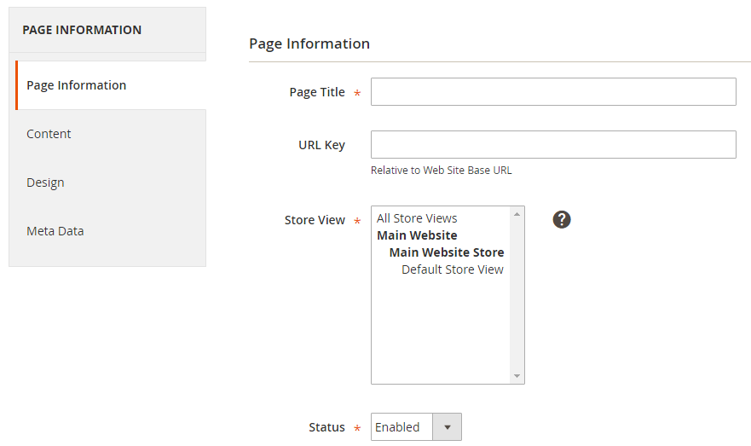

Under the Page Information section:

* Fill out the Page Title, the meta data that shows in the title bar and tab of the browser.
* Fill out a URL Key for the page, added to the base URL for the new online address of the page.

Remember to insert lowercase characters and hyphens without spaces.

* In the Store View list, choose the store view which the page is displayed on.
* Set Disable if it is not ready to go live, but don’t forget to come back and enable the page status to make it available.
* Click on Save and Continue Edit.

### Step 2: Choose the Page Layout

* On the left panel, tap the Design tab.
* In the Layout field, choose one of the options from the dropdown list of the page layout.
  + 1 column
  + 2 columns with left bar
  + 2 columns with right bar
  + 3 columns

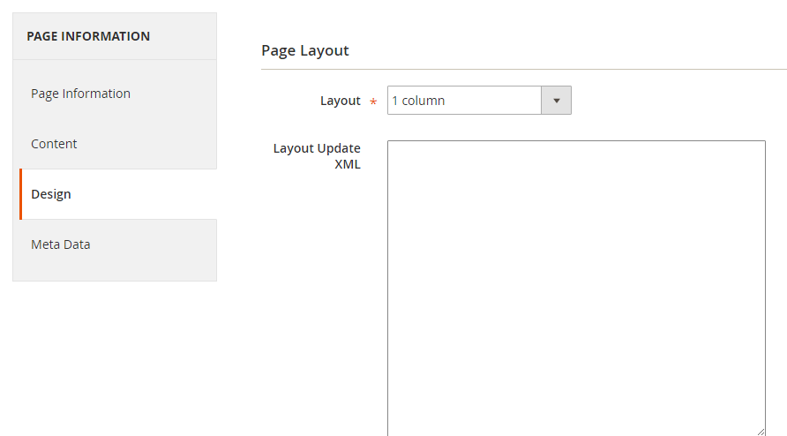

Scroll down to customize the page design. On the Custom Design section, you can change theme, layout, and style within exact time period like holiday or sales.

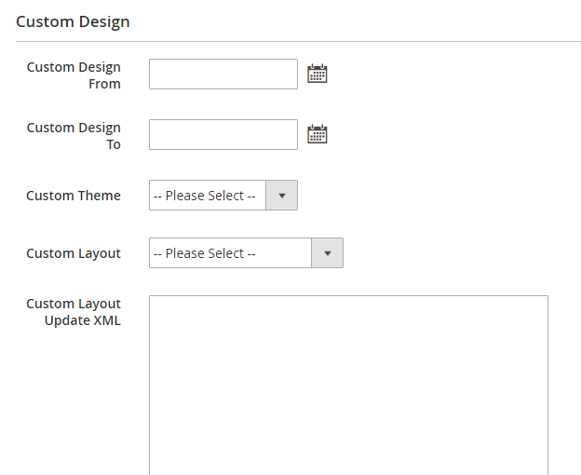

### Step 3: Enter the Content

* On the left panel, tap the *Content8 tab.
* In the Content Heading field, enter the main heading at the top of the page.
* Click on Show/Hide Editor button to edit the text with the WYSIWYG editor.

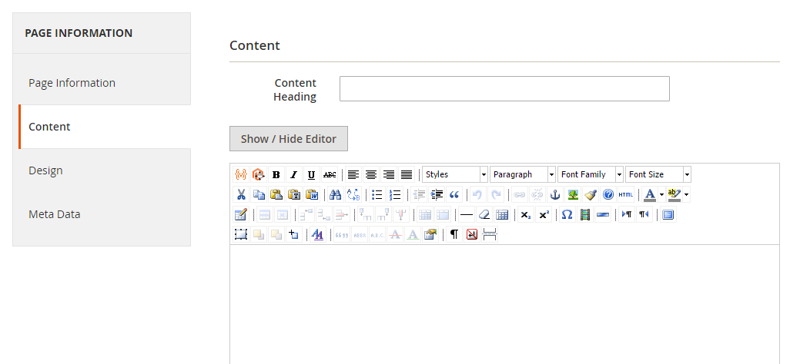

Hit the Save and Continue Edit

### Step 4: Fill out the Meta Data

* On the left panel, tap the Meta Data tab.
* Enter the Keywords and Description for the CMS page, that is necessary for [SEO](https://marketplace.magento.com/mageplaza-magento-2-seo-extension.html).
* Hit the Save and Continue Edit.

### Step 5: Preview the Page

To ensure that all settings are perfect as well as you want to check the formatting, on the upper-right corner, click on Preview link.

### Step 6: Generate the Page

* Return to Page Information and set Status to Enabled.
* Hit the Save page.

That is all for adding a new page, and now it is ready to be included in your store navigation, or link to other pages, even you can also apply it for your new home page.

## Assign a Home Page

You can assign any page as a Home Page according to the following guide:

* Finish all steps to create a new page.
* On the Admin Panel, Stores > Settings > Configuration.
* On the left panel, under General, select Web.
* Open the Default Pages section,
  + Set CMS Page as Home Page in the CMS Page field.
  + Save Config to activate the settings.
* Click on the Cache Management link in the system message to flush your cache.

